**Install Node:**

1. Go to <https://nodejs.org/en/download/> and choose the 64-bit .msi version for Windows installer. If you have 32-bit windows, choose the 32-bit one, but I assume everyone has 64-bit.
2. Once the download is complete, open the installer.
   1. Accept terms and conditions.
   2. Installation folder can remain the default Program files.
   3. Custom setup can remain as it is.
   4. Tools for native modules: not necessary to choose the box.
   5. Complete setup. If prompted, type in your Bouvet email and password.
3. When the install is complete, in the bottom left corner of your screen type “command prompt” or “terminal” and open the application. Type node -v in the terminal and hit enter. You should get the version number of the installed Node on your PC as a response. You may need to restart your PC before you get the response.  
     
   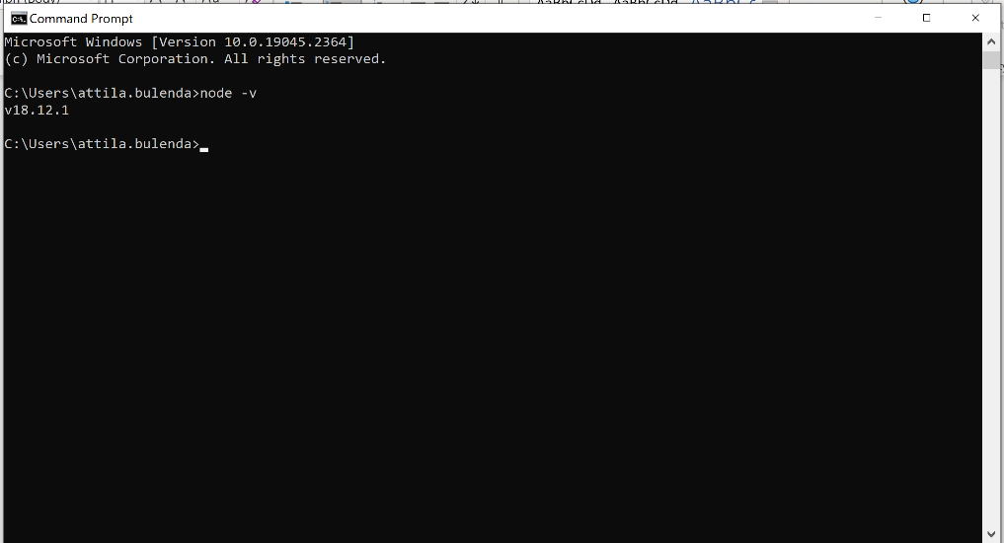

**Install VS Code:**

1. Go to <https://code.visualstudio.com/download> and choose the 64-bit user installer.
2. Accept terms and conditions, installation folder can remain the same, start menu name can remain the same.
3. Addition tasks:  
   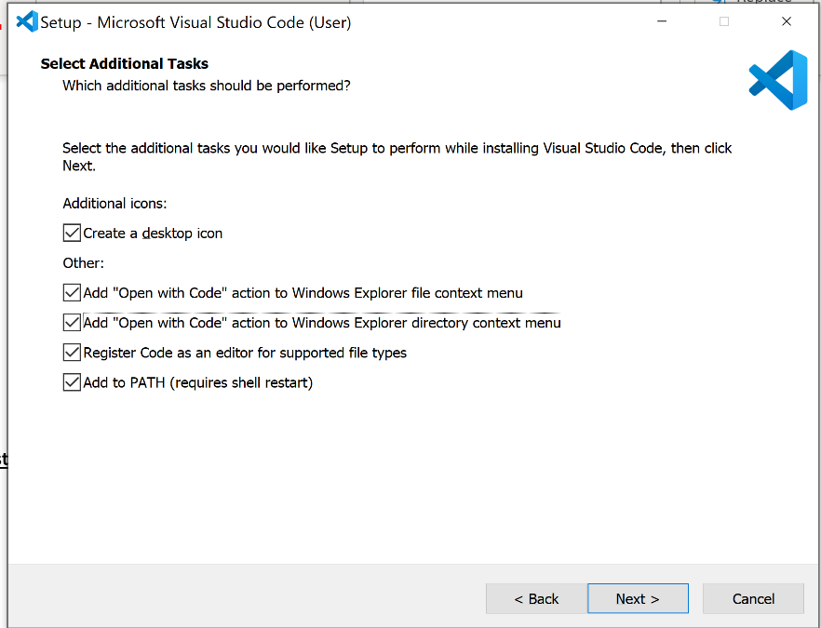
4. Open VS Code and choose your preferred settings. I choose dark mode because it is better for my eyes, but choose your own preference.
5. On the top menu select Terminal > New terminal. Type node -v in the open terminal and see if it gives back the version of Node. If not restart your PC and do it again.
6. Choose extensions:  
   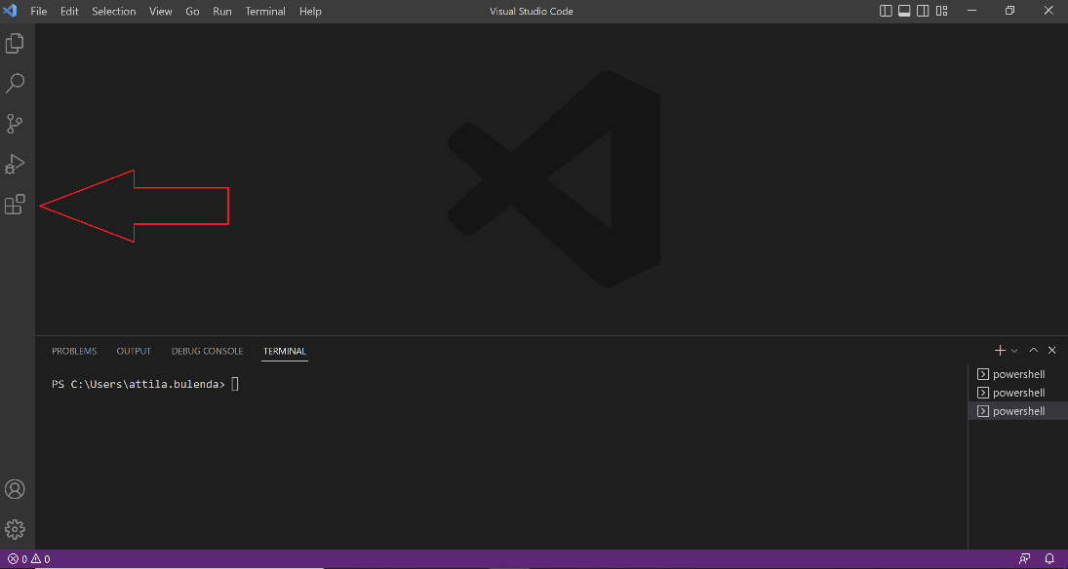
7. Search and install the following extensions:
   1. JavaScript (ES6) code snippets
   2. Prettier - Code formatter
   3. Auto Rename Tag

**Install GitHub Desktop:**

1. Go to <https://github.com/> and create a free account.
2. Go to <https://desktop.github.com/>, download, and open the application.
3. When prompted, sign in with your github account. On the Configure Git page, choose “Use my GitHub account name and email address”.
4. Click on create a new repository.
5. Set up the local repository just like on this screenshot. The local path should be changed to a new folder on your Desktop, or anywhere where you prefer on your laptop.  
   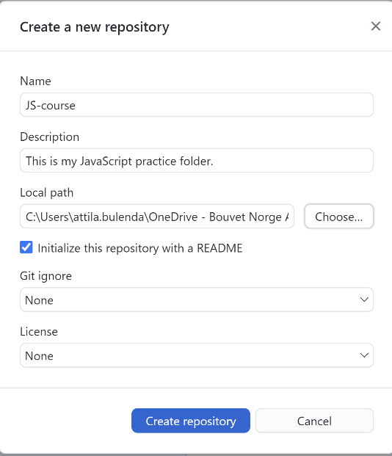
6. Click on publish repository:  
   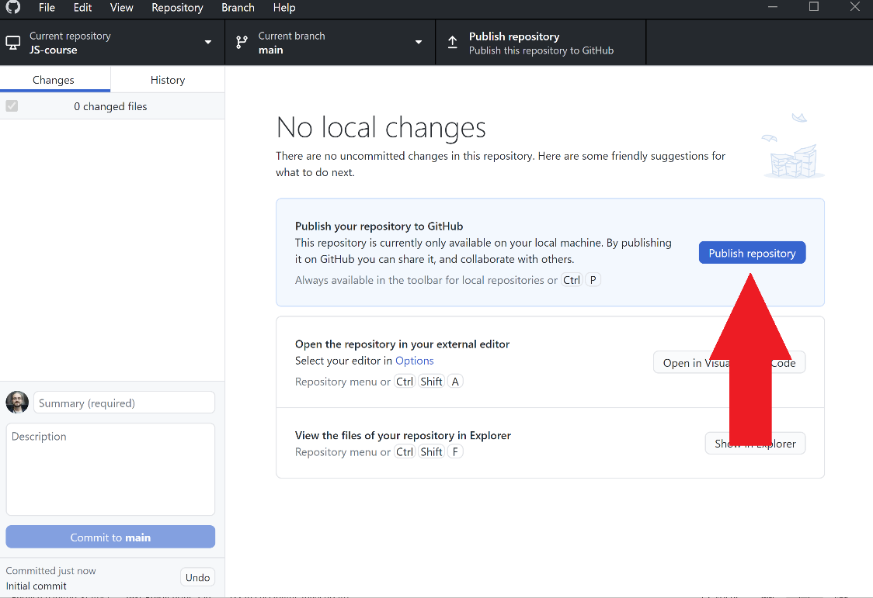
7. In the popup unselect “Keep this code private”. If you accidentally leave it on, we can change it later, don’t worry. You can let me know when we meet to change it to public.
8. Sign in to your github account in the browser, and select your repositories:  
   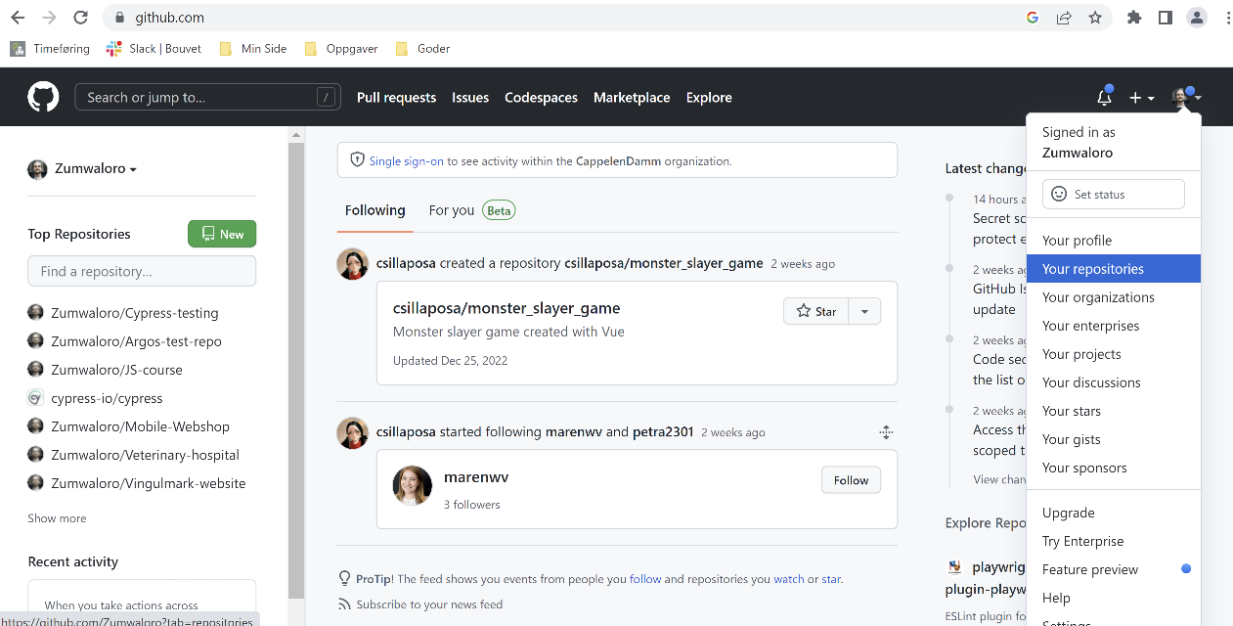
9. Your JS course repository should be now visible in your remote github account:  
   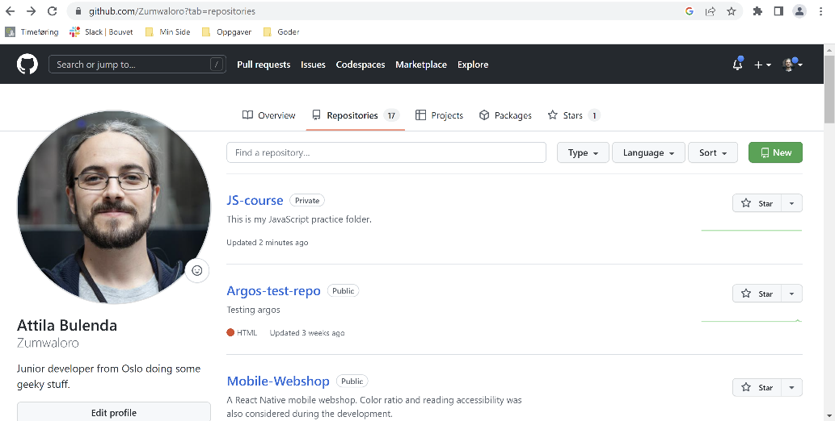

This is all. If you have any further questions, you can contact me on [Attila.bulenda@cappelendamm.no](mailto:Attila.bulenda@cappelendamm.no). I can react faster on my project e-mail address. I only check my Bouvet account once or twice a day.